Unit 1 - Worksheet 5:

Energy Bar Charts with the Observation Stations

*As before, refer to your Activity 1 observations and your representations in Worksheet 1 to help you recall these events and construct Energy Bar Charts.**NOTE: It will also help if you have read “Reading 3: Constructing Energy Bar Charts” before or after you begin this worksheet.*

**Directions:**

1. Identify and list the objects you are considering part of the system of interest for the following events you observed in the Activity 1 Energy Stations.
2. Construct an Energy Bar Chart to show the initial and final energy storage modes and any energy transfers that take place in each of these events. If you think there is a storage mode missing on the bar chart, add it and be prepared to explain your thinking!
3. *Where appropriate*, include State Diagrams for each of your Energy Bar Charts.
4. 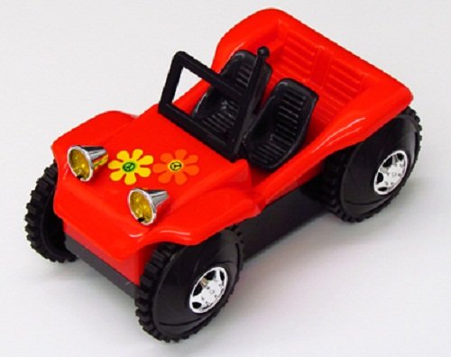The Tumble Buggy drives up a ramp.

Ek Ech Eel Eint

Ek Ech Eel Eint

Initial

Energy

0

Final

Energy

0

**System/Flow**

1. 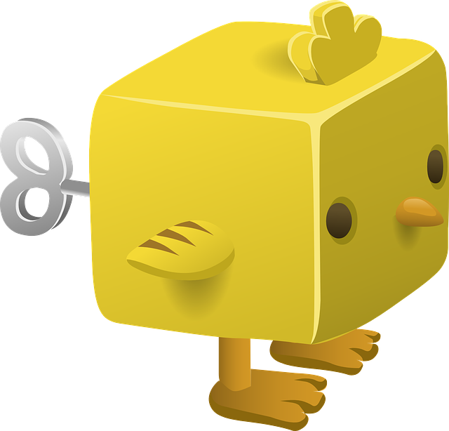A wind-up toy, that is already “wound up” is released and walks across the table.

Ek Ech Eel Eint

Ek Ech Eel Eint

Initial

Energy

0

Final

Energy

0

**System/Flow**

1. Ball Drop Analysis 1: Initial state – a single ball before being dropped

Final state – the ball, right before it strikes the floor.



Ek Eg Eel Eint

Ek Eg Eel Eint

Initial

Energy

0

Final

Energy

0

**System/Flow**

1. Ball Drop Analysis 2: Initial state – the ball, just after striking the floor the first time

Final state – the ball at the top of its first bounce.

Ek Eg Eel Eint

Ek Eg Eel Eint

Initial

Energy

0

Final

Energy

0

**System/Flow**

1. 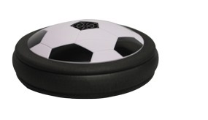A student kicks an air puck on the level classroom floor.

Ek Eg Eel Eint

Ek Eg Eel Eint

Initial

Energy

0

Final

Energy

0

**System/Flow**

1. 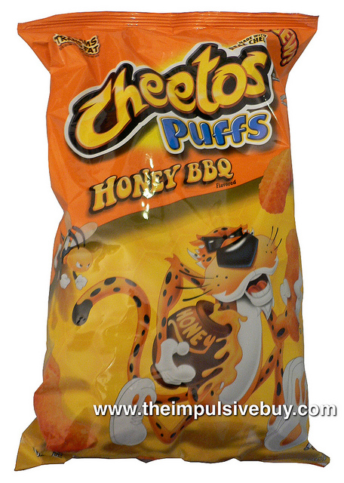A Cheeto sitting in an aluminum pan is ignited and burns for 2 minutes.

Ech Eint

Ech Eint

Initial

Energy

0

Final

Energy

0

**System/Flow**

1. A piece of ice melts when left on the kitchen counter.

Initial

Energy

0

Final

Energy

0

**System/Flow**

Eth Eph Ech

Eth Eph Ech